System.out.print("Hi tell me your name");

System.out.print("My name is chaitanya");

--> **output** : Hi tell me your name My name is chaitanya

System.out.println("Hi tell me your name");

System.out.println("My name is chaitanya");

--> **output** : Hi tell me your name

My name is chaitanya (because println will print output in nxt line)

-->Type of statements in java

In Java, there are several types of statements that can be used to perform different operations. Some of the most common types of statements in Java include:

**Expression Statements**: These statements are used to evaluate an expression and can include method calls, assignments, and other operations.

**Declaration Statements**: These statements are used to declare a new variable or constant and specify its type.

**Control Flow Statements**: These statements are used to control the flow of execution in a program, including if-else statements, switch statements, loops (for, while, do-while), and try-catch statements.

Jump Statements: These statements allow the program to jump to a specific part of the code, including break, continue, and return statements.

Assertion Statements: These statements are used to check assumptions made by the programmer and throw an error if the assertion fails.

Synchronized Statements: These statements are used to control access to shared resources in a multithreaded environment.

Labeled Statements: These statements are used to provide a label to a block of code, which can be used for easy navigation and readability.

Block Statements: These statements are used to group a set of statements together, which can be treated as a single unit for control flow or variable scoping.

--> Data Types in Java derived into two types

1) Primitive Data Types

2) Non-Primitive Data Types

**Primitive Data types** are derived into byte,short,int,long,float,double,boolean,char

Primitive data types imp types are int,long,float,double,boolean,char

String is reference data type

Primitive Data types Reference/User Defined Data Types

Stores data stores address

Can hold only 1 value can hold more than 1 value

Less memory more memory

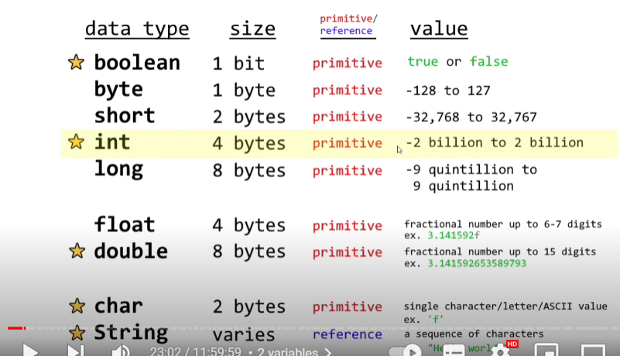

-->Variables and Data Types in Java:

**Variables** : Variables are containers for storing data values.

How to declare a variable in java?

Int x;

x= 18;

Or int x=18;

Double vs float   
  
Default Type for Floating-Point Literals:

* Floating-point literals (e.g., **3.14**) are considered as **double** by default in Java. If you want to explicitly declare a **float** literal, you can append an 'f' or 'F' to the number (e.g., 3.14f).

**Swapping of 2 strings** :

String x = "Chaitanya";

        String y = "Virat";

        String temp;

        temp = x;

        x = y;

        y = temp;

        System.out.println("Value of x is "+x);

        System.out.println("Value of y is "+y);

**UserInput in Java:**

We use scanner for occuring input from user

Scanner scanner = new Scanner(System.in);

For this one we will use a utility package

import java.util.Scanner;

scanners are used to read contents of file

 public static void main(String[] args) {

        String a;

        Scanner scanner = new Scanner(System.in);

        System.out.println("Please enter your name?");

        a = scanner.nextLine();

        System.out.println("Enter your age");

        int b = scanner.nextInt();

        scanner.nextLine();

        System.out.println("what is your fav food");

        String c = scanner.nextLine();

        System.out.println("enter your favourite subject :");

        String d = scanner.nextLine();

        System.out.println("Hello"+ a);

        System.out.println("You are " + b +"yearsold");

        System.out.println("you like "+ c);

        System.out.println("your favorite subject is "+d);

    }

After using scanner.nextInt(); we need to use this method as

Scanner.nextLine(); because it will used to take our next line input, without writing this command we can’t able to get next input.  
  
  
Expressions in java : expressions is combination of operands and operations in java.

Operands are nothing but values,numbers,variables,quantity.

Operators are +,-,*,/ %

public static void main(String[] args) {

        int a=18;

        a++;

        System.out.println("a is "+a);

        double c = 15;

        c = 15/4;

        System.out.println("c is "+c);

        double d = 15;

        d = (double)15/4;

        System.out.println("d is "+d);

    }

Output :

a is 19

c is 3.0

d is 3.75

**Gui:** graphical user interface

We need to use are utility package as   
import javax.swing.JOptionPane;

We will use to enter input by using

JOptionPane.showInputDialog("Enter your name:");

To display entered message we use

 JOptionPane.showMessageDialog(null, "Hello "+name);

Here JOptionpane is String data type to convert string data type we use ParseInt()

For Double we use parsedouble()

public static void main (String[] args){

        String name = JOptionPane.showInputDialog("Enter your name:");

        JOptionPane.showMessageDialog(null, "Hello "+name);

        int age = Integer.parseInt(JOptionPane.showInputDialog("Enter your age =:"));

        JOptionPane.showMessageDialog(null,"You are "+age+ "years old");

        Double height = Double.parseDouble(JOptionPane.showInputDialog("Enter your height"));

        JOptionPane.showMessageDialog(null,"you are "+ height+"cm height");

    }

**Math functions:**

Max method is used to identify larger number.

Min method used to find smallest number.

Abs method is used to display absolute value of a number.

Sqrt()round()

Ceil,floor used to round a decimals.

    double x = 3.14;

        double y = -10;

        double z = Math.max(x, y);

        System.out.println("Larger number is ="+z);

        double v = Math.min(x, y);

        System.out.println("smallest number is ="+v);

        double w = Math.abs(x);

        System.out.println("absolute number is"+w);

        double opp,adj,hyp;

        Scanner scanner = new Scanner(System.in);

        System.out.println("Enter Opposite side:");

        opp = scanner.nextDouble();

        System.out.println("Enter Adjacent side:");

        adj = scanner.nextDouble();

        hyp = Math.sqrt((opp*opp)+(adj*adj));

        System.out.println("Hypotenuse of given rt trianle is "+hyp);

        scanner.close();

    }

**Random values in java** :

For this we need to use utility package as

import java.util.Random;

We need to use are utility package as   
import java.util.Random;

public static void main (String [] args){

        Random random = new Random();

        int x = random.nextInt();

        // here random will generate - 2 billion to + 2 billion

        int w = random.nextInt(7);

        // if we use bound as 7 it will generate from 0 to 7

        double y = random.nextDouble();

        //it will generate only from 0 to 1

        boolean z = random.nextBoolean();

        System.out.println("x is"+x);

        System.out.println("w is"+w);

        System.out.println("y is"+y);

        System.out.println("z is"+z);

    }

Output :

x is1418537660

w is4

y is0.32604087309639884

z istrue

**If statements**:

Performs a block of code if its condition evaluates to be true

// package conditional statements;

public class if1 {

    public static void main(String[] args){

        int a = 16;

        if(a>= 18){

            System.out.println(" you are adult since you have "+a+" years");

        }

        else if (a >=75)

        {

            System.out.println("You are a old one");

        }

        else if (a >= 13 & a<18)

    {

        System.out.println("you are a teenager");

    }

        else{

            System.out.println("you are not adult");

        }

    }

}

**Switch Statements:**

It is a statement that allows a variable to tested for equality against a list of values.

public class switchs {

    public static void main(String[] args){

        String day = "Monday";

        switch(day){

            case "Sunday":System.out.println("Its sunday");

            break;

            case "Monday":System.out.println("Its Monday");

            break;

            case "Tuesday":System.out.println("Its Tuesday");

            break;

            case "Wednesday":System.out.println("Its Wednesday");

            break;

            case "Thursday":System.out.println("Its Thursday");

            break;

            case "Friday":System.out.println("Its friday");

            break;

            case "Satuday":System.out.println("Its satarday");

            break;

            default:System.out.println("Please select a week day");

        }

    }

**Three logical operators :**

Used to connect 2 or more expressions

&& And both conditions must true

|| OR either condition must be true

! NOT reverse Boolean value of condition

public class logicaloperators {

    public static void main(String [] args){

        int temp = 25;

        if(temp>30){

            System.out.println("It is hot outside");

        }

        else if(temp >= 20 && temp <=30){

            System.out.println("It is warm outside");

        }

        // forand both conditions must true

        else{

            System.out.println("It is cold outside");

        }

    }

}

public class orusingif {

    public static void main(String [] args){

        Scanner scanner = new Scanner(System.in);

        System.out.println("You are playing a game! Press q or Q to quit");

        String response = scanner.next();

        if(response.equals("q")|| response.equals("Q")){

            System.out.println("You quit the game!");

        }

        else{

            System.out.println("You are still in game!");

        }

    }

}

**While loop:**

It executes a block of code as long as its condition remains true.

,

"vmArgs": "--module-path \"C:/Program Files/Java/javafx-sdk-21/lib\" --add-modules javafx.controls,javafx.fxml"